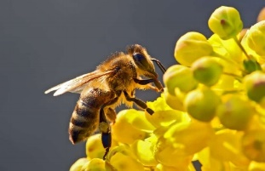

**“WHERE FLOWERS BLOOM SO DOES HOPE”**

**LADY BIRD JOHNSON** This institution is an equal opportunity provider.

SOFT SHELL TACO BEEF

REFRIED BEANS, CORN

LETTUCE, CHEESE SHREDDED

FRUIT VARIETY

BROWNIE

MILK CHOCOLATE FAT FREE

MILK 1% LOWFAT

ORANGE CHICKEN RICE, BROCCOLI

FRUIT VARIETY

FORTUNE COOKIE

MILK CHOCOLATE FAT FREE

MILK 1% LOWFAT

What flowers grow on faces?  
Tulips (Two-lips)!

CHICKEN NUGGETS

FRENCH FRIES

GREEN BEANS

FRUIT VARIETY

RANGER COOKIE

MILK CHOCOLATE FAT FREE

MILK 1% LOWFAT

SCALLOPED POT W/ HAM

ROLL

PEAS & CARROTS

FRUIT VARIETY

MILK CHOCOLATE FAT FREE

MILK 1% LOWFAT

BURRITO, BEAN & CHEESE

NACHO CHIPS

NACHO CHEESE SAUCE

FRUIT VARIETY

MILK CHOCOLATE FAT FREE

MILK 1% LOWFAT

Can bees fly in the rain?

Not without their [yellow jackets!](https://thesimpleparent.com/spring-jokes-for-kids/)

PIZZA W/ PEPPERONI

SALAD, TOSSED

TOMATO, CHERRY

FRUIT VARIETY

MILK CHOCOLATE FAT FREE

MILK 1% LOWFAT

SPAGHETTI WITH MEAT SAUCE

TEXAS GARLIC TOAST

CARROTTS

FRUIT VARIETY

MILK CHOCOLATE FAT FREE

MILK 1% LOWFAT

CORN DOG

TATER TOTS

VEGGIE CUP

FRUIT VARIETY

MILK CHOCOLATE FAT FREE

MILK 1% LOWFAT

Why are frogs so happy?

[They eat whatever bugs them.](https://www.everythingmom.com/jokes-for-kids/spring-jokes-for-kids)

NEW YORK SUB SANDWICH

SUN CHIPS, VEGGIE CUP

FRUIT VARIETY

SUGAR COOKIE

MILK CHOCOLATE FAT FREE

MILK 1% LOWFAT

CHICKEN FAJITA

CORN

REFRIED BEANS

FRUIT VARIETY

MILK CHOCOLATE FAT FREE

MILK, 1% LOWFAT

CHICKEN SANDWICH

LETTUCE, SHREDDED

PICKLES

FRENCH FRIES

FRUIT VARIETY

MILK CHOCOLATE FAT FREE

MILK 1% LOWFAT

HAMBURGER ON A BUN

BAKED BEANS

BABY CARROTTS

FRUIT VARIETY

MILK CHOCOLATE FAT FREE

MILK 1% LOWFAT

Does February like March?

[No, but April May.](https://www.artsyfartsymama.com/2020/03/free-printable-spring-jokes.html)



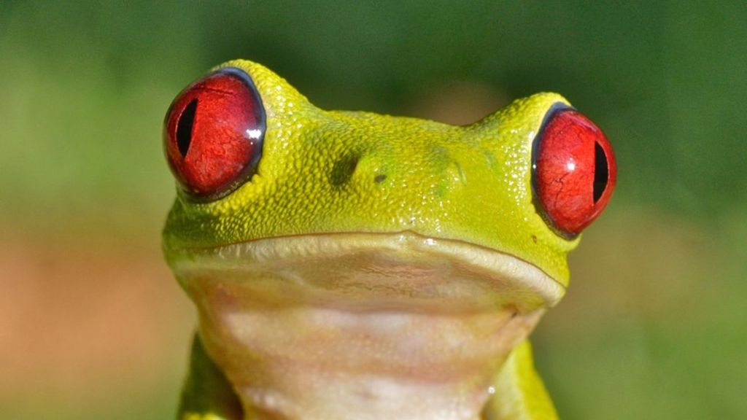

HAVE A LOVELY

SPRING BREAK!

Why is the letter A like a flower?

[A “b” comes after it!](https://www.artsyfartsymama.com/2020/03/free-printable-spring-jokes.html)

PIZZA RIPPERS

SALAD, TOSSED

TOMATO, CHERRY

FRUIT VARIETY

PUDDING

MILK CHOCOLATE FAT FREE

MILK 1% LOWFAT

**APRIL 2021**

Garfield School District