

**Spring is when life is alive in everything.** Christina Rosetti

This institution is an equal opportunity provider.

i

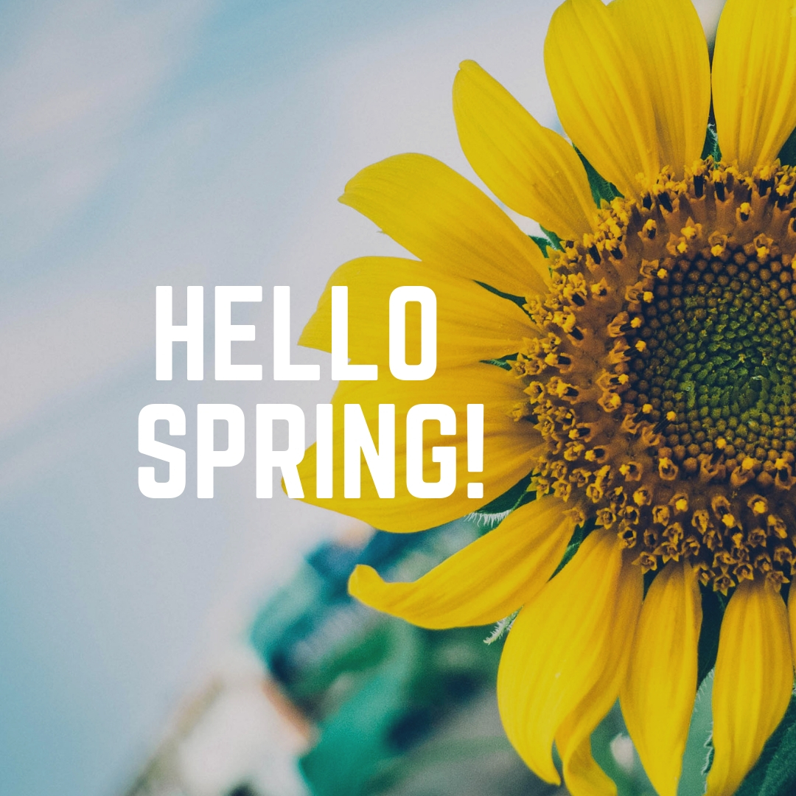

BELGIAN WAFFLE

SYRUP

FRUIT VARIETY

JUICE, ASSORTED,

MILK CHOCOLATE FAT FREE

MILK 1% LOWFAT

CEREAL-ASST

STRING CHEESE

APPLES, ORANGES

YOGURT, POP TART

GRANOLA BAR, MUFFIN

JUICE

MILK CHOCOLATE FAT FREE

MILK 1% LOWFAT

MAPLE BITES

YOGURT, ASST.

FRUIT VARIETY

JUICE, ASSORTED,

MILK CHOCOLATE FAT FREE

MILK 1% LOWFAT

BREAKFAST SANDWICH

YOGURT, ASST.

FRUIT VARIETY

JUICE, ASSORTED,

MILK CHOCOLATE FAT FREE

MILK, 1% LOWFAT

PIZZA

FRUIT VARIETY

JUICE, ASSORTED,

MILK CHOCOLATE FAT FREE

MILK, 1% LOWFAT

PANCAKE ON A STICK,

FRUIT VARIETY

JUICE, ASSORTED,

MILK CHOCOLATE FAT FREE

MILK, 1% LOWFAT

CEREAL-ASST

STRING CHEESE

APPLES, ORANGES

YOGURT, POP TART

GRANOLA BAR, MUFFIN

JUICE,

MILK CHOCOLATE FAT FREE

MILK 1% LOWFAT

HASH BROWNS

SAUSAGE PATTY

FRUIT VARIETY

JUICE, ASSORTED,

MILK CHOCOLATE FAT FREE

MILK 1% LOWFAT

FRENCH TOAST STIX

SYRUP

FRUIT VARIETY

JUICE, ASSORTED,

MILK CHOCOLATE FAT FREE

MILK 1% LOWFAT

PANCAKES

SYRUP

FRUIT VARIETY

JUICE, ASSORTED,

MILK CHOCOLATE FAT FREE

MILK, 1% LOWFAT

CEREAL-ASST

STRING CHEESE

APPLES, ORANGES

YOGURT, POP TART

GRANOLA BAR, MUFFIN

JUICE,

MILK CHOCOLATE FAT FREE

MILK 1% LOWFAT

PIZZA

FRUIT VARIETY

JUICE, ASSORTED,

MILK CHOCOLATE FAT FREE MILK

MILK, 1% LOWFAT

MAPLE BITES

YOGURT, ASST.

FRUIT VARIETY

JUICE, ASSORTED,

MILK CHOCOLATE FAT FREE MILK

MILK 1% LOWFAT

APPLE CINNAMON TEXAS TOAST

FRUIT VARIETY

JUICE, ASSORTED,

MILK CHOCOLATE FAT FREE

MILK 1% LOWFAT

BELGIAN WAFFLE

SYRUP

FRUIT VARIETY

JUICE, ASSORTED,

MILK CHOCOLATE FAT FREE

MILK 1% LOWFAT

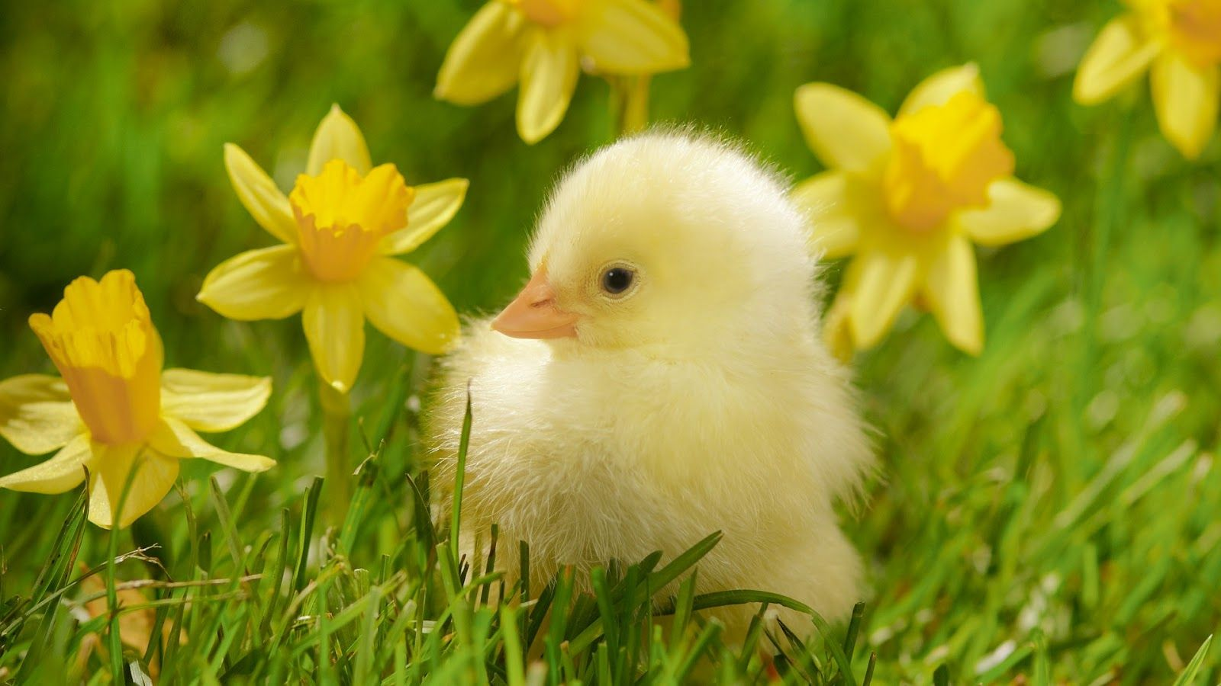

CEREAL-ASST

STRING CHEESE

APPLES, ORANGES

YOGURT, POP TART

GRANOLA BAR, MUFFIN

JUICE

MILK CHOCOLATE FAT FREE

MILK 1% LOWFAT

FRENCH TOAST STIX W/SYRUP

FRUIT VARIETY

JUICE, ASSORTED,

MILK CHOCOLATE FAT FREE MILK

MILK 1% LOWFAT

**APRIL 2021**

Garfield School District

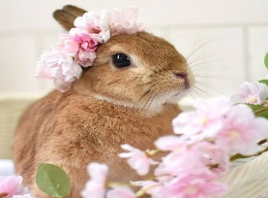Have a

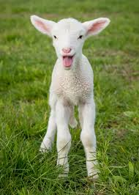

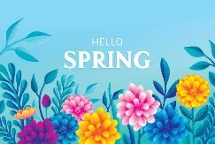Lovely Spring Break!