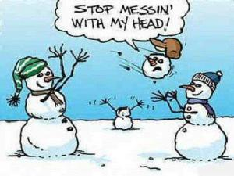

SCALLOPED POT W/ HAM,

ROLL, PEAS & CARROTS,

FRUIT, ASST

MILK CHOCOLATE FAT FREE

MILK 1% LOWFAT

CORN DOG

BAKED BEANS

BABY CARROTS, FRUIT, ASST

MILK CHOCOLATE FAT FREE

MILK 1% LOWFAT

SOFT SHELL TACO (BEEF)

REFRIED BEANS, SALSA, CHEESE, LETTUCE, FRUIT,

MILK CHOCOLATE FAT FREE

MILK 1% LOWFAT

CHICKEN NOODLE SOUP

BREADSTICK, CHEESE FILLED

FRUIT, ASST

MILK CHOCOLATE FAT FREE

MILK 1% LOWFAT

PIZZA W/ PEPPERONI

SALAD, FRUIT, ASST

CHOCOLATE PUDDING

MILK CHOCOLATE FAT FREE

MILK 1% LOWFAT

SPAGHETTI W/ MEAT SAUCE,

TEXAS GARLIC TOAST

CARROTS, FRUIT, ASST

MILK CHOCOLATE FAT FREE

MILK 1% LOWFAT

HAMBURGER ON A BUN

FRENCH FRIES

VEGGIE STIX FRUIT, ASST

MILK CHOCOLATE FAT FREE

MILK 1% LOWFAT

BURRITO, BEAN & CHEESE

TORTILLA CHIPS, SALSA

VEGGIE STIX, FRUIT, ASST

MILK CHOCOLATE FAT FREE

MILK 1% LOWFAT

NEW YORK SUB SANDWICH

POTATO CHIPS, VEGGIE CUP

FRUIT, SUGAR COOKIE

MILK CHOCOLATE FAT FREE

MILK 1% LOWFAT

COUNTRY FRIED STEAK

GRAVY, MASHED POTATOES

CORN ROLL, FRUIT, ASST

MILK CHOCOLATE FAT FREE

MILK 1% LOWFAT

CHICKEN NUGGETS,

FRENCH FRIES, GREEN BEANS

FRUIT, RANGER COOKIE

MILK CHOCOLATE FAT FREE

MILK 1% LOWFAT

This institution is an equal opportunity provider.

]

CORN DOG

POTATO WEDGES,

VEGGIE STICKS, FRUIT, ASST

MILK CHOCOLATE FAT FREE

MILK 1% LOWFAT

What did the zero say to the number 8?

**Nice Belt**

CHICKEN SANDWICH

SUN CHIPS, FRUIT, ASST

VEGGIE CUP, PICKLES,

MILK CHOCOLATE FAT FREE

MILK 1% LOWFAT

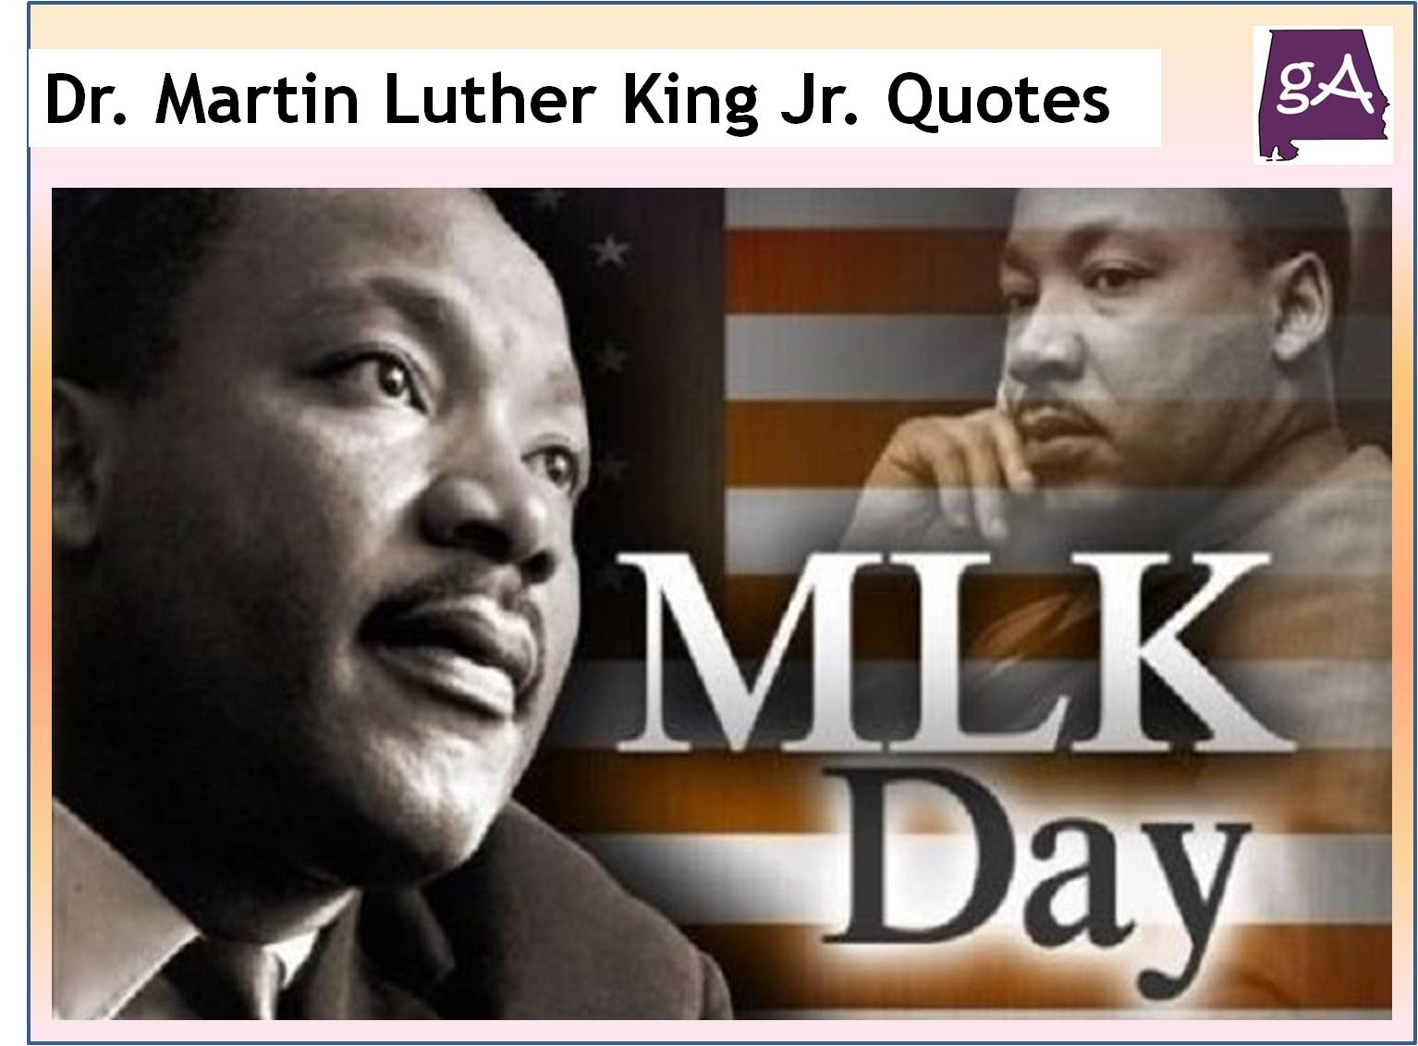

**What do you call a snowman in August?**  
**A puddle**

**What is a snowman’s favorite snack?**  
**Ice Krispy treats**

HAPPY

NEW

YEAR!

**JANUARY 2021**

Garfield School District

ORANGE CHICKEN

RICE, BROCCOLI

FORTUNE COOKIE, FRUIT

MILK CHOCOLATE FAT FREE

MILK 1% LOWFAT

PIZZA PEPPERONI,

SALAD, FRUIT, ASST

BUTTERSCOTCH PUDD.

MILK CHOCOLATE FAT FREE

MILK 1% LOWFAT