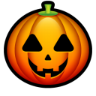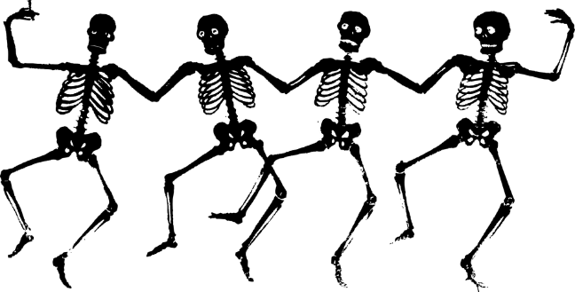

This institution is an equal opportunity provider.

***All meals for students’ k-12 are Free this month!***

Tomato Soup

Cheese Sandwich

Baby carrots, Fruit

Milk Chocolate Fat Free

Milk 1%

Orange Chicken

Rice, Broccoli

Fortune Cookie

Milk Chocolate Fat Free

Milk 1%

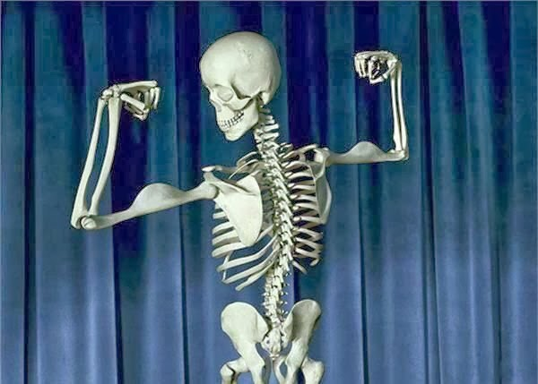

Hamburger

French Fries

Veggie Sticks, Asst.Fruit

Milk Chocolate Fat Free

Milk 1%

Chili, Crackers

Baby Carrots

Asst. Fruit

Milk Chocolate Fat Free

Milk 1%

Corn Dog

Potato Wedges

Veggie Sticks/Asst.Fruit

Milk Chocolate Fat Free

Milk 1%

Pizza Rippers

Salad

Milk Chocolate Fat Free

Milk 1%

Pudding w/cream

Why didn’t the Skeleton like the Halloween Candy?

*He didn’t have the Stomach for it.*

Macaroni &Cheese

Green Beans, Roll

Asst. Fruit

Milk Chocolate Fat Free

Milk 1%

When did the Skeleton say “Trick or Treat?”

*On Halloween!*

*Be Safe Have Fun!*

BBQ PULLED PORK

BAKED BEANS

COLE SLAW

FRUIT

MILK CHOCOLATE FAT FREE MILK1%

MILK 1% LOWFAT

Soft Shell Taco

Refried Beans, Corn

Asst. Fruit

Milk Chocolate Fat Free

Milk 1%

Chicken Alfredo

Cheese Breadstick

Broccoli, Brownies

Milk Chocolate Fat Free

Milk 1%

What instrument do Skeletons play?

*A TromBONE*

How do you make a Skeleton Laugh?

*Tickle his Funny Bone.*

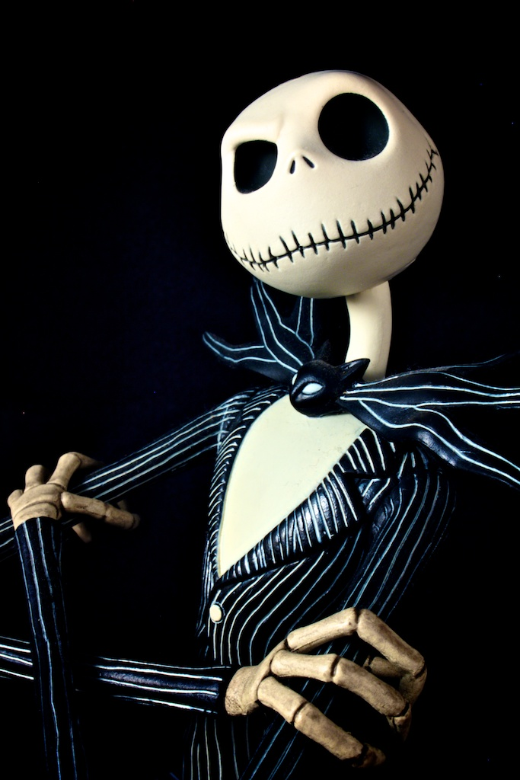

No School

Harvest Holiday

Chicken Nuggets

French Asst. Fruit

Milk Chocolate Fat Free

Milk 1%

Ranger Cookies

Fries

Pizza Rippers

Salad

Milk Chocolate Fat Free

Milk 1%

Pudding w/cream

Chicken Sandwich

Corn Asst. Fruit

Milk Chocolate Fat Free

Milk 1%

New York Sub

Potato Chips

Veggie Sticks/Asst.Fruit

Milk Chocolate Fat Free

Milk 1%

Corn Dog

Potato Wedges

Veggie Sticks/Asst.Fruit

Milk Chocolate Fat Free

Milk 1%

**OCTOBER 2020**

Garfield County School District