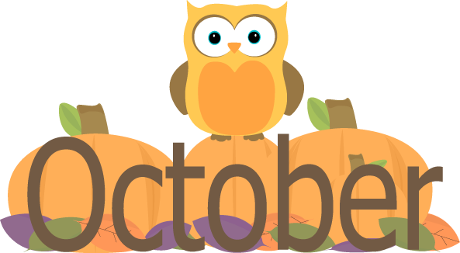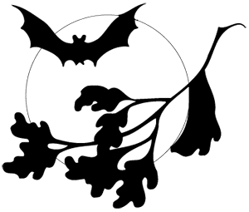
HOT LUNCH MENU
Monday | Tuesday | Wednesday | Thursday | Friday
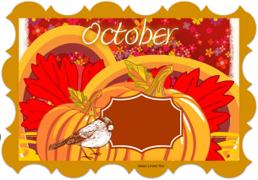 | 1  Chicken Noodle Soup  Breadstick w/ cheese  Baby Carrots  Apple Crisp  Fruit, assorted  Milk, variety | 2  Country Fried Steak  Mashed Potatoes  Country Gravy  Roll, WG  Green Beans  Fruit, assorted  Milk, variety | 3  Hamburger  French Fries  Veggie Cup  Fruit, assorted  Milk, variety | 4
7  Spaghetti  Texas Garlic Toast  Steamed Carrots  Fruit, assorted  Milk, variety | 8  Chicken Alfredo  Breadstick w/cheese  Broccoli  Brownie  Fruit, assorted  Milk, variety | 9  Chili  Crackers  Baby Carrots  Cinnamon Roll  Fruit, assorted  Milk, variety | 10  Pizza Rippers,  Salad, Tossed  Tomato, cherry  Butterscotch Pudding  Fruit, assorted  Milk, variety | 11  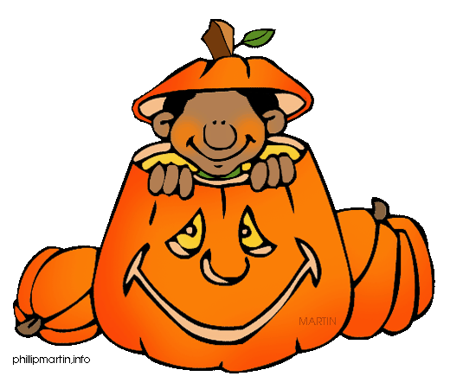
14  Chicken Nuggets  French Fries  Cookie  Fruit, assorted  Milk, variety | 15  Salisbury Steak  Mashed Potatoes  Brown Gravy  Roll, WG  Calif. Blend Veggies  Fruit, assorted  Milk, variety | 16  Sott Shell Taco (Beef)  Refried Beans  Corn  Fruit, assorted  Milk, variety | 17  New York Sub  Potato Chips  Veggie Sticks  Fruit, assorted  Milk, variety | 18 FALL BREAK – NO SCHOOL
21 FALL BREAK – NO SCHOOL  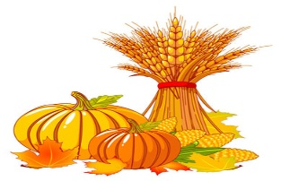 | 22  Tomato Soup  Cheese Sandwich  Carrots/ Pickles  Fruit, assorted  Milk, variety | 23  Pulled Pork Sandwich  Baked Beans  Cole Slaw  Biscuit WG  Fruit, assorted  Milk, variety | 24  Corn Dog  Potato Wedges  Green Beans  Fruit, assorted  Milk, variety | 25  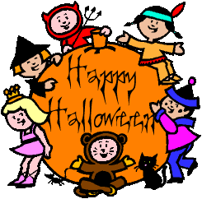
28  Teacher’s Professional Day – NO SCHOOL | 29  Chicken Parmesan  Breadstick  Corn  Fruit, assorted  Milk, variety | 30  Mac & Cheese  Green Beans  Baby Carrots  Fruit, assorted  Milk, variety  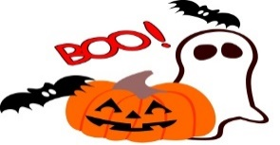 | 31  Orange Chicken  Rice, Broccoli  Fortune Cookie  Fruit, variety  Milk
Menu is Subject to Change
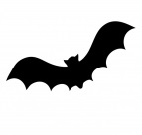USDA is an Equal Opportunity Employer