Hot Breakfast Menu
Monday | Tuesday | Wednesday | Thursday | Friday
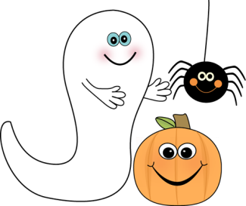 | 1  Breakfast Round  Fruit, assorted  Juice, assorted  Milk | 2  French Toast Stix  Syrup  Fruit, asst.  Juice, asst.  Milk | 3  Pancake on a Stick  Syrup  Fruit, asst.  Juice, asst.  Milk | 4  Grab ‘N Go  Juice, asst.  Fruit, asst.  Milk
7  Pizza Bagel  Fruit, assorted  Juice, assorted  Milk | 8  Pancakes  Syrup  Fruit, assorted  Juice, assorted  Milk | 9  Apple Cinnamon Texas Toast  Fruit, assorted  Juice, assorted  Milk | 10  Maple Bites  Yogurt, asst.  Juice, assorted  Fruit, assorted  Milk | 11  Grab “N Go  Juice, asst.  Fruit, asst.  Milk
14  French Toast Stix  Syrup  Fruit, assorted  Juice, assorted  Milk, variety | 15  Belgian Waffle  Syrup  Fruit, assorted  Juice, assorted  Milk, variety | 16  Bagel  Yogurt  Fruit, assorted  Juice, assorted  Milk, variety | 17  Breakfast Sandwich  Syrup  Fruit, assorted  Juice, assorted  Milk, variety | 18  FALL BREAK – NO SCHOOL
21  FALL BREAK – NO SCHOOL  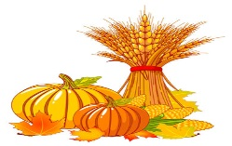 | 22  Breakfast Burrito  Fruit, assorted  Juice, assorted  Milk, variety | 23  Pancake on a Stick  Syrup  Fruit, assorted  Juice, assorted  Milk, variety | 24  Apple Cinnamon Texas Toast  Fruit, assorted  Juice, assorted  Milk, variety | 25  Grab ‘N Go  Fruit, assorted  Milk, variety
28  Teacher’s Professional  Day – NO SCHOOL  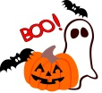 | 29  Maple Bites  Yogurt  Fruit, assorted  Juice, assorted  Milk, variety | 30  Breakfast Rounds  Yogurt  Fruit, assorted  Juice, assorted  Milk, variety | 31  French Toast Stix  Syrup  Fruit, asst.  Juice, asst.  Milk  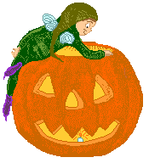 | 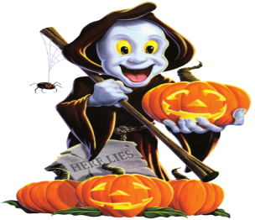
Menu is Subject to Change

USDA is an Equal Opportunity Employer