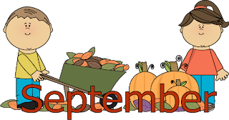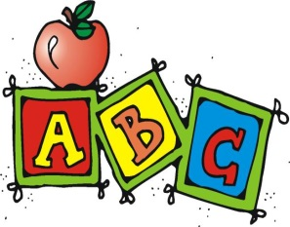
Hot Breakfast Menu
Monday | Tuesday | Wednesday | Thursday | Friday
2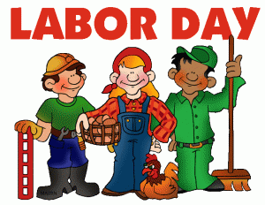 | 3  Breakfast Round  Yogurt  Fruit, asst.  Juice, variety  Milk | 4  French Toast Stick  Syrup  Fruit, asst.  Juice, variety  Milk | 5  Pancake on a Stick  Syrup  Fruit, asst.  Juice, variety  Milk | 6  Grab N Go  Fruit, asst.  Juice, variety  Milk
9  Breakfast Pizza  Fruit, asst.  Juice, variety  Milk | 10  Pancakes  Syrup  Fruit, asst.  Juice, variety  Milk | 11  Apple Cinnamon Toast  Fruit, asst.  Juice, variety  Milk | 12  Maple Bites  Yogurt  Fruit, asst.  Juice, variety  Milk | 13  Grab N Go  Fruit, asst.  Juice, variety  Milk
16  French Toast Sticks  Syrup  Fruit, asst.  Juice, variety  Milk | 17  Belgian Waffle  Syrup  Fruit, asst.  Juice, variety  Milk | 18  Bagel  Cream Cheese  Fruit, asst.  Juice, variety  Milk | 19  Breakfast Sandwich  Fruit, asst.  Juice, variety  Milk | 20  Grab N Go  Fruit, asst.  Juice, variety  Milk
23  Pancakes  Syrup  Fruit, asst.  Juice, variety  Milk | 24  Breakfast Burrito  Fruit, asst.  Juice, variety  Milk | 25  Pancake on a Stick  Syrup  Fruit, asst.  Juice, variety  Milk | 26  Apple Cinnamon Toast  Fruit, asst.  Juice, variety  Milk | 27  Grab N Go  Fruit, asst.  Juice, variety  Milk
30  Maple Bites  Yogurt  Fruit, asst.  Juice, variety  Milk |  | 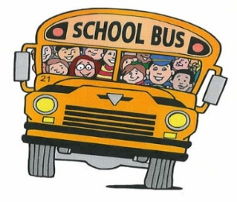 | 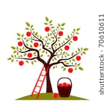 | 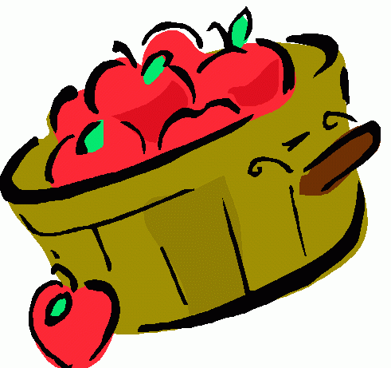
Menu is Subject to Change. Milk is 1% white, or Skim Chocolate

This institution is an equal opportunity provider

