HOT LUNCH MENU
AUGUST
Monday | Tuesday | Wednesday | Thursday | Friday
 |  |  | 1 | 2
5 | 5 | 7 | 8 | 9
12 | 13 | 14 | 15 | 16
19  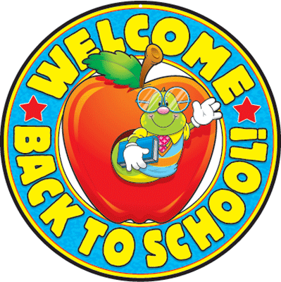 | 20  Pizza Rippers  Salad, tossed  Tomatoes, cherry  Fruit, asst.  Milk, variety | 21  Soft Shell Taco  Refried Beans  Bread Sticks  Baby Carrots  Fruit, asst.  Milk, variety | 22  New York Sub Sandwich  Potato Chips, asst.  Veggie Cup  Fruit, asst.  Cookie  Milk, variety | 23
26  Chicken Parmesan  Noodles  Breadstick w/cheese  Green Beans  Fruit, asst.  Milk, variety | 27  Burrito, Bean/Cheese  Nacho Chips  Nacho Cheese sauce  Salsa  Fruit, asst.  Milk, variety | 28  Hamburger on a bun  French Fries  Lettuce, Pickles  Baby carrots  Fruit, asst.  Milk, variety | 29  Mac & Cheese  Broccoli  Fruit, asst.  Brownie  Milk, variety | 30
MENU IS SUBJECT TO CHANGE – Milk is 1% White, or Skim Chocolate

THIS INSTITUTION IS AN EQUAL OPPORTUNITY EMPLOYER

